The Benefice Of The Lower Swale

United Parish of Ainderby Steeple with Yafforth
and Kirby Wiske with Maunby
www.lowerswalechurches.org.uk

Newsletter for December 2017

01609 773346
Letter from The Rectory

Who would believe that it is coming up to Christmas again?
I know a number of people who are just waiting for this year to end because they have had such a difficult one, and I feel encouraged that even though they have had such a hard time they still have the hope that next year will be better.
Christmas is about hope.
Not just the hope of presents and parties and time to forget difficulties and be together with family and friends, but the hope of the Kingdom of God; the rule of love.
The classic story in the gospel of Luke of Mary and Joseph and the baby Jesus; of difficulties overcome and joy acknowledged; of the shepherds being privileged over the rich rulers and wise men bringing gifts, tells us about hope on all kinds of different levels. It tells of the hope of a young mother that she has a healthy child; of a father that he can provide for every situation; of shepherds that they might be acceptable and of travellers that they might find their way. It tells us about how love overcomes all impossible obstacles and transforms any difficult situation so that everyone feels good about themselves and who they are.
I hope that this is true for you this Christmas; that you are touched by love and are transformed by it, so that next year has a bright new beginning, full of hope for all it has to offer and one step closer to the Kingdom of God.
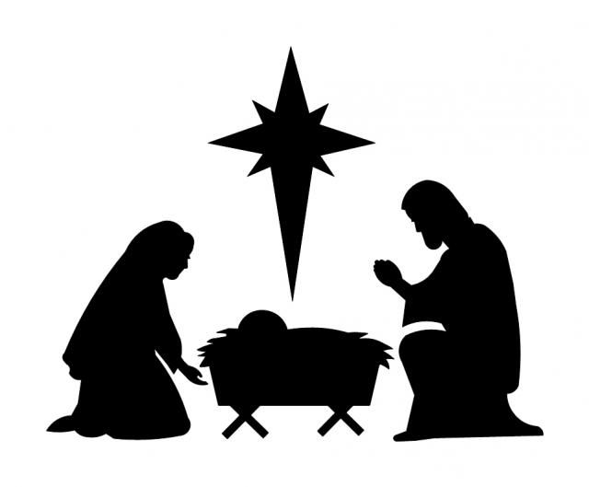
Blessings of the Season, Ann

Information for the January Newsletter by December 8th please

Benefice Evensong: 6.30pm on Sunday 10th December at St John the Baptist Church, Kirby Wiske
Ainderby Steeple News

St Helen’s 100 Club winners:
September - 1st prize: No.5 J.Atkinson; 2nd prize: No. 99 A.Galvin
October - 1st prize: No.60 C.Todd; 2nd prize: No.31 M.Sherwood
November - 1st prize: No.6 M.Sherwood; 2nd prize: No.99 A.Galvin

Morton on Swale News

Mobile Post Office: The van parks in the layby outside the Old Chapel each Wednesday from 12.30-1pm and offers a range of service. It is accessible for everyone.

Children's Christmas Party: at the village hall on Saturday December 2nd at 4 pm.
Santa will be there. Tickets £3.00 contact 01609 779447

Christmas Quiz: at the village hall with Ged the quizmaster: Saturday December 9th at 7.30 pm. Pie and peas supper, bar, tombola and prizes. All proceeds to the Chairpersons Chosen Charity - The Alzheimer's Society. Tickets £5.00 - contact 01609 779447

To book the Village Hall for your own event please contact Lynne on 07718 370677
Yafforth News

100 Club Winners October: C Enon £20; J Atkinson £10
Tickets for Christmas and the coming year will be available from the end of this month

Yafforth Hub: The Hub has made a good start, with increasing numbers.
There is no Hub in December and the meetings will restart on Saturday 13th January 2018

Christmas:
Christingle at Yafforth 4:30 pm on Sunday 3rd December

Carols and Readings on Christmas Eve at 7:00 pm

See posters for more info.

Parish News

Benefice Evensong: 6.30pm on Sunday 10th December at St John the Baptist Church, Kirby Wiske
Ainderby Steeple News

St Helen’s 100 Club winners:
September - 1st prize: No.5 J.Atkinson; 2nd prize: No. 99 A.Galvin
October - 1st prize: No.60 C.Todd; 2nd prize: No.31 M.Sherwood
November - 1st prize: No.6 M.Sherwood; 2nd prize: No.99 A.Galvin

Morton on Swale News

Mobile Post Office: The van parks in the layby outside the Old Chapel each Wednesday from 12.30-1pm and offers a range of service. It is accessible for everyone.

Children's Christmas Party: at the village hall on Saturday December 2nd at 4 pm.
Santa will be there. Tickets £3.00 contact 01609 779447

Christmas Quiz: at the village hall with Ged the quizmaster: Saturday December 9th at 7.30 pm. Pie and peas supper, bar, tombola and prizes. All proceeds to the Chairpersons Chosen Charity - The Alzheimer's Society. Tickets £5.00 - contact 01609 779447

To book the Village Hall for your own event please contact Lynne on 07718 370677
Yafforth News

100 Club Winners October: C Enon £20; J Atkinson £10
Tickets for Christmas and the coming year will be available from the end of this month

Yafforth Hub: The Hub has made a good start, with increasing numbers.
There is no Hub in December and the meetings will restart on Saturday 13th January 2018

Christmas:
Christingle at Yafforth 4:30 pm on Sunday 3rd December

Carols and Readings on Christmas Eve at 7:00 pm

See posters for more info.

Carol Service: Please join us for the service of readings and carols at 7.0pm on Friday 15th December, in St John the Baptist church. Enjoy seasonal refreshments afterwards.
Kirby Wiske News
Church Decoration: We shall be decorating the church from 9.30 am on Friday 15th December. Everyone welcome to come and help.
Village Hall News:
- Suggested film evening on hold at present.
- Thursday 21st December at 7.0 pm villagers invited to join in Carol Singing round the village Christmas tree followed by mulled wine and mince pies by the Hall fireside. Carol sheets provided, voices needed.
- Next Hall Committee meeting at 7.0pm on Thursday 4th January 2018

Local History Group: The Christmas Lunch will be held at the Dog and Gun on Tuesday 12th December at 12 noon.

Parish Council Meeting: on Tuesday 5th December at 7.30 pm in the village hall.

January dates for your diary:
- Friday 19th January at 7.30pm, Wine Tasting "Call My Bluff" evening. Details of this very popular event available in the January newsletter.
- Friday 26th January, Pie and Peas supper and Quiz in aid of church roof fund. Details later.

Rota. Sidesmen: 15th December 7.0pm, Mrs M Dale; 17th December 9.30 am Mrs M Dale;
25th December 10.0am Mrs M Dale
Cleaning: Mrs G Green & Mrs D Statham Flowers: Mrs S Rodgers

Maunby News

Carol Service: Sunday 17th December at 6.30 pm. More readers are still needed for this popular village event, volunteers please contact Ann Quinn on 01609 760356
Methodist Church Rota: 3rd December: Miss L Bustard; 10th December: Revd D Godfrey;
17th December tbc; 24th December: Mr J Parkinson; 31st December: U@NMC
Youth Groups

Date | Busy Bees | Groovers & Shakers | Trendy Teens
7/12/17 | 4-5pm | 6.15pm-8.00pm
14/12/17 |  |  | 6.30pm-8.30pm
Back on January 11th with Busy Bees and Groovers and Shakers

